**Jira**

* Jira is a project management tool.
* It is developed by Atlassian.

**Jira Account Setup**

* <https://www.atlassian.com/software/jira/free>

**Create Project**

* Go to project 🡪 Software Development

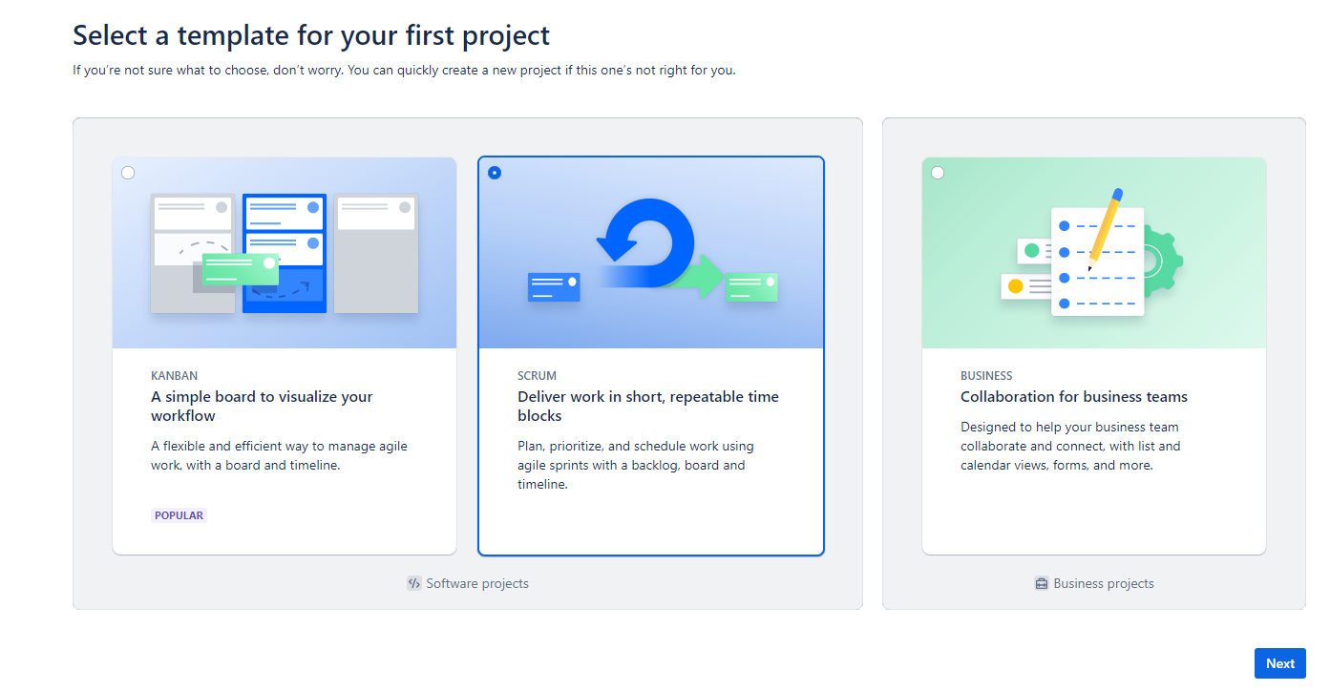

**Project Page**

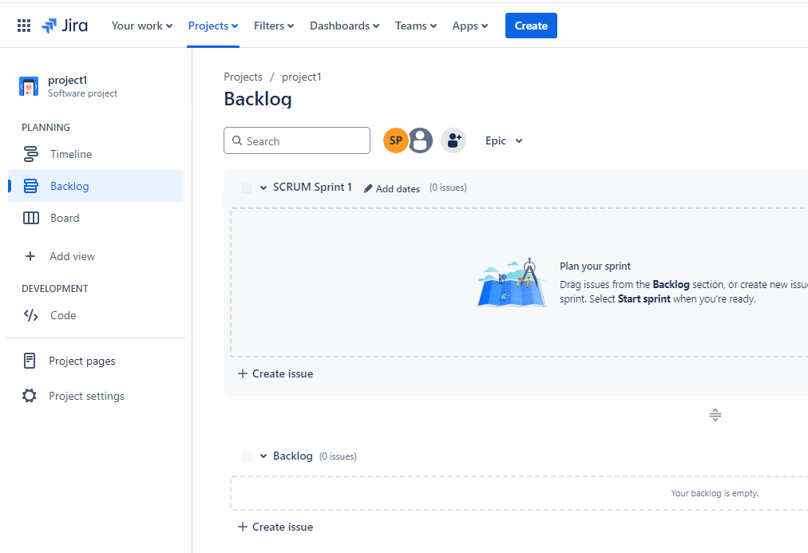

**Adding people to Jira project**

* Settings
* User Management
  + Add Email
  + Send Invitations

**Create EPIC**

* Create based on requirement (e.g. ETL pipeline)

**Create backlogs/ User Stotries**

* Click on Create
* Issue Type: Story
* Summary: ..
* Assignee:
* Priority: Medium
* Epic: epicname
* Add Story Points

Example:

* Extract data from source systems.
* Transform data to fit the target system.
* Load transformed data into the data warehouse.
* Monitor and maintain the ETL pipeline.

**Create Sprint**

* + Click on Create Sprint
  + Input:
    - Name:
    - Start Data:
    - End Date:
    - Goals:

**Add Stories to the Sprint**

* + Drag and drop stories from backlog to sprint

**Start Sprint**

* + Name: sprint 1
  + Duration: 2 weeks
  + Start date:
  + End Date:
  + Sprint Goal:

**Add Task to stories**

* + Click on stories -> Create Subtask / Add Child Issue

**Update User story with description and acceptance criteria**

**As a** Data Engineer,

**I want to** extract data from various sources,

**So that** I can put it into a centralized data warehouse for analysis.

**Acceptance Criteria:**

Identifies and documents all sources and data formats.

Access permissions for all source systems are documented.

Scripts are developed to extract data from each sources.